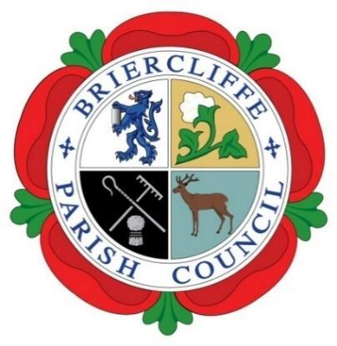
Briercliffe with Extwistle Parish Council

ANNUAL PARISH MEETING.

Thursday 8th May 2025 at 7.30pm at Briercliffe Community Centre.

Present: Councillors Gordon Lishman, Michael McFarlane, Michael Greenwood, Pippa Lishman and John Marlow.

In Attendance: Councillor Anne Kelly, County Councillor Mark Poulton and R Greenwood (Temp Clerk)

The Chair, Councillor Gordon Lishman opened and welcomed all to the meeting, including Mark Poulton as the new County Councillor.
 | Actions by Clerk | Cllr Support
24/25/0318 Apologies for absence
Apologies were received and accepted from Councillor Roger Frost, Carrie Halstead, and Libby Lalor

24/25/0319 Disclosable Pecuniary Interest
No Councillors declared any pecuniary interest.
Councillors were asked to update their Register of Interest Forms.

24/25/0320 Minutes of the meeting held 30th May 2024
The minutes of the meeting held 30th May 2024 were accepted as a true record.
24/25/0321 Chairs report for the municipal year 2024/25
The Chair, Gordon Lishman reported that the past year had achieved so much with no small thanks to the hard work of the councillors. He thanked Michael Greenwood and Pippa Lishman for their work on Projects and Events –and for their work in getting the administration work up to date and their sterling work on the garages and allotments and John Marlow for his practical contribution. He also thanked Roger Frost for his continued work on planning matters and Michael McFarlane, Vicky Balmer and Richard Sagar for their support on staffing matters and R Greenwood for her work in getting on top of administrative and organisational matters.

He noted some priorities for the next year including:
- The appointment of a long term clerk and Responsible Financial Officer.
- Development of a local Neighbourhood Plan.
- To consider the impact of the local government reorganization with LCC to be replaced by a combined authority and new Unitary Authorities. Prior to this, the Council should review land ownership for the Council and Community Assets including the Thursden Picnic site, the George VI Recreation Ground, Briercliffe Memorial Bowling Green, Netherwood Woodlands and part of the industrial estate.

24/25/0322 Financial report for the municipal year 2024/25
- The parish council was in the unfortunate position in the last year of having to pay two clerks. This has now been resolved.
- For the new financial year, the Precept has had a small increase to cover some of the new costs associated with Briercliffe Community Centre.
- In the new financial year, the allotment and garages account will run separately to the general account to ensure that there is no inappropriate cross-subsidy and including a small admin fee paid from the allotment and garages account to the general account.

24/25/03023 Date of the next Annual Parish Meeting.
The date for the next Annual Parish Meeting will be Thursday 14th May 2026 after the parish council elections.

